**GameStop to GameStart**

GameStop is a video game retailer that was founded in 1994. It is headquartered in Grapevine, Texas, and operates over 5,000 retail stores worldwide. The company specializes in the sale of new and pre-owned video game hardware, software, and accessories, as well as other gaming-related products such as collectibles and consumer electronics. GameStop also offers a variety of services, including trade-ins and repair services, and operates an online store where customers can purchase video games and other gaming-related products. Flash forward to midway through 2021, GameStop nearly went bankrupt, but a silver lining saved them. Let’s see why.

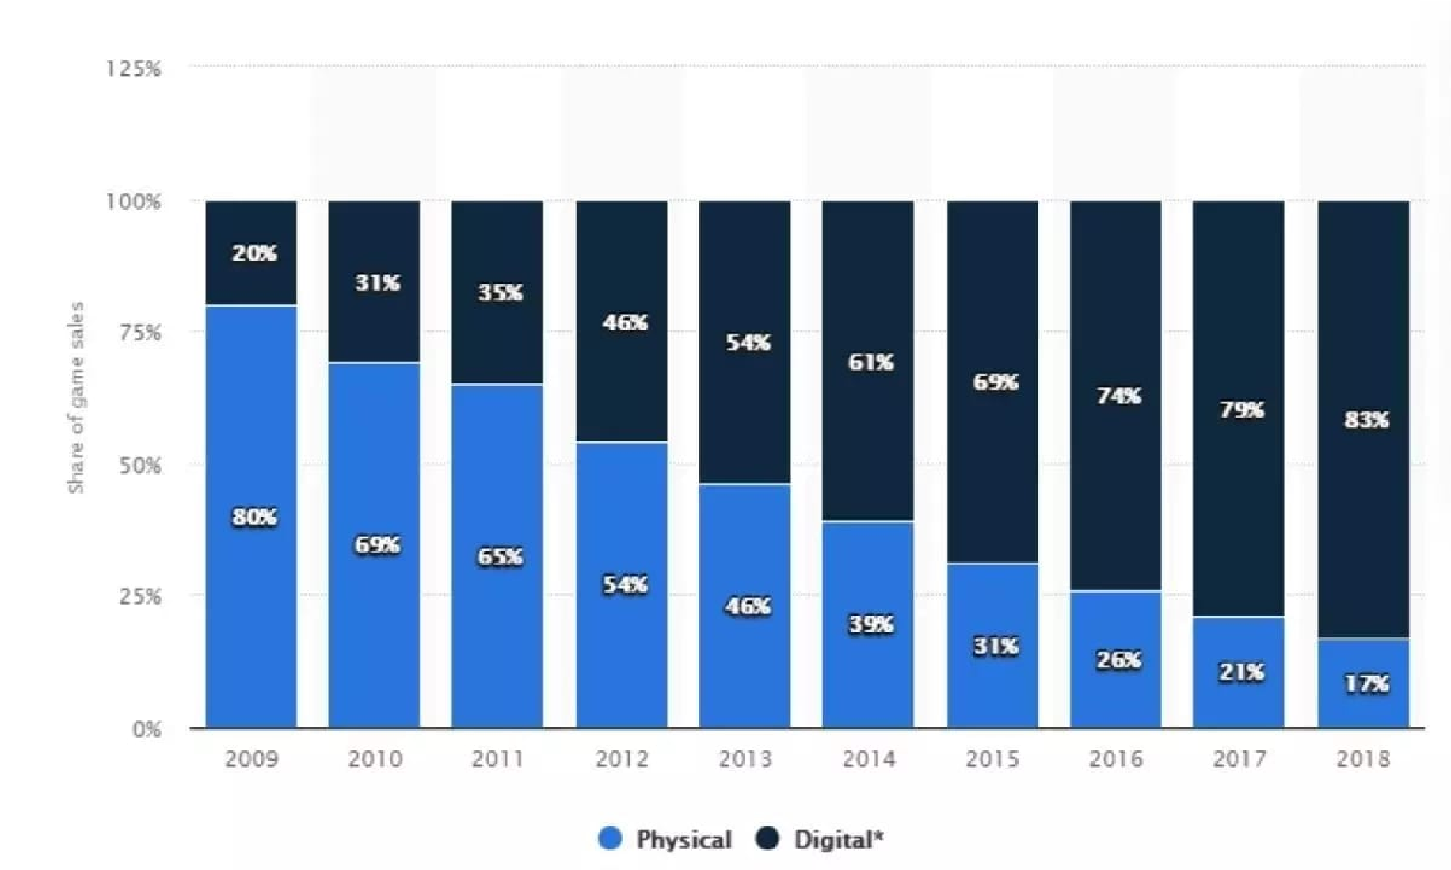

In recent years, the company has faced challenges due to the increasing popularity of digital downloads and online marketplaces. The above graph illustrates why GameStop, a typical brick-and-mortar retailer, struggled to thrive. There are a few reasons why GameStop may have missed the shift towards digital distribution in the video game industry. A strong reason is that the company may have been slow to adapt to the changing market. As more and more consumers began purchasing games digitally, GameStop may have been slow to respond and adjust its business model to meet the demand for digital products.

# Failure, Comeback, and Future

|  |
| --- |
| We might never be able to pinpoint the exact reasons for their downfall, but |

One cannot imagine GameStop, one of the world’s largest video game retailers in the world, having to face obsoletion. Lauded as the place to be for gamers all around the world, they suddenly faced the challenge of being completely wiped out by the rise of the Internet. What was supposed to be the dawn of something great turned into a nightmare for GameStop. But why was this happening? Was it a lack of incentive to switch to digital, having opened close to 5000 retail stores worldwide, or it could be the fact that the hierarchy were operating with a tunnel vision and were not looking at what was going on in and around the industry.

we do need to answer one important question, “Is GameStop destined to become yet another

Blockbuster?”

|  |
| --- |
| saved |

Ironically, the thing that almost killed them was the one that gave them a lifeline. The Internet came together to save GameStop from being bullied by big hedge fund managers who had shorted the GameStop stock because they thought their current stock price was overvalued and betted against it, but the Redditors on the subreddit r/wallstreetbets thought otherwise. Gaining much traction due to the meme investing rounds which acts as an antonym to traditional Wall Street investing, GameStop soared to new heights in the stock market. This unprecedented surge in stock pricesGameStop from their impending doom. This upturn in luck has the potential to trigger a positive change in the company’s outlook towards the Internet and the digital age, and they shouldn’t shy away from it.

|  |
| --- |
| certain |

Like any company, GameStop has faced a number of challenges and has had to adapt to changing market conditions. In recent years, the company has faced competition from digital downloads and online retailers, which has impacted its sales. In response, GameStop has made efforts to diversify its business and expand its offerings beyond just physical game sales. This includes the addition of new product lines such as consumer electronics and collectibles, as well as the expansion of its online presence through initiatives such as the launch of a digital storefront and the acquisition ofe-commerce assets. They also recently launched a digital wallet that allows users to store, send and receive cryptocurrencies and NFTs. Having received a new lease of life, the onus is on GameStop to revamp its business model and venture into uncharted territories. This might not be a straightforward process and might involve lots of divergent and convergent thinking, overhaul of the top brass of the company, setting up a cloud infrastructure and a lot more but it certainly is not an impossible task.

# New Goals and Paths

Due to the internet, GameStop's business model faces substantial challenges. Since more people are purchasing games online, fewer people are purchasing physical discs from GameStop. To regain its footing, GameStop must define a set of goals and reimagine its business processes to achieve them.

* By the middle of 2024, sixty percent of their revenue should come from online streaming.
* Obtain at least 15% of the market's customer base, or the gamers, by the end of 2025.
* Increase annual net revenue by at least $600 million over the following three years.

GameStop must alter its business practices significantly to meet these goals. As a result of the rise of online streaming services, GameStop is no longer the go-to destination for pre-owned video games, as pre-owned games simply ceased to exist.

# Reimagining Business Processes to Meet Goals

|  |
| --- |
| Marketing, R&D, Information |

Most business processes need to be restructured for the digital business transformation of GameStop. For our research purposes, we have taken up four departments:

Technology, and Finance. Our Digital Business is now a platform, we must consider the users of this platform: Gamers and Game Developers. Now let’s proceed with the changes each department will go through to grow the platform.

## Transform 60% of their existing business to online streaming by mid-2024

After transitioning to digital, GameStop should abandon the brick-and-mortar business model. Finance plays a significant role in allocating key resources to IT infrastructure. GameStop's top priority is to withdraw from a failing physical business. To host and deploy video games, a new cloud infrastructure must be built. In order to gain access to games, the marketing division must convince Game Developers to use GameStop's Platform.

## Creating a Platform for Growth

GameStop should create an online streaming service similar to Netflix for PC games only. The PC gaming market has immense potential and will never decline. No matter which consoles they ultimately switch to, PC gaming is always the starting point. GameStop should target this market of PC game publishers and retailers. One side of the platform will be occupied by PC game developers, who will be incentivized to create more content by using it as a platform for less popular games. More users will play more games if there are more games available at lower prices, and if subscriptions are also available. There would therefore be significant cross-side network effects.

The primary difference between GameStop and other cloud gaming platforms is that the majority of the latter are multiplayer or arcade platforms with poor-quality games. GameStop would host high-end games similar to those on Steam on its platform and make them available to customers in subscription-based bundles. Customers will have more options and consequently be more engaged if high-quality games are available for a lower subscription-based package price. Even well-known game developers will want to host their games on GameStop now that more PC gamers are using the platform because users will be able to try the game before deciding to purchase it on their website. In addition, game developers will benefit because now that there is a market for their less popular games, more individuals will be able to play them.

## Garner at least 15% of the digital gaming market’s user base by the end of 2025

The only strategy for a platform to survive is to get big fast. To survive in this Digital Gaming market, GameStop must obtain a substantial portion of the market share. Marketing the new platform is essential to achieving this objective. To switch from their current game provider, individuals need inducements such as bundled games and cross-platform games. In addition, they must convince gaming industry titans such as Sony, Nintendo, and Microsoft to join their platform so that gamers have access to fresh and original content. The IT infrastructure must be continuously upgraded and maintained as the number of games and players increases.

## Incentivize the growing customer base to help customer retention

Personalized bundles that are distinct from standard, one-type bundles, customer loyalty programs from when they were brick-and-mortar stores, and lower prices than market leaders. Although the latter will delay their profitability, it is the best course of action.

Form partnerships with EA, Activision, and other major PC game developers in order to restore the quality of PC games. This can aid in customer retention by providing already-available games at a reduced price. In order to gain exclusivity, GameStop may consider creating original content once they reach a significant size.

Additionally, GameStop could collaborate with independent game developers. They could be significantly less expensive whilst also expanding the market for niche content.

## Increase net annual income to at least $600 million by the end of 2026

A platform can only become profitable after it has a huge number of users on each side. With the marketing department working to garner users for the platform it is important to add personalization to GameStop’s Digital Business. The R&D department is the most important aspect of personalization. STP (Segment, Target, and Position) is the best marketing strategy, GameStop can use to pull users from all walks of life. Digital Customizations and Personalization need to be incorporated into the platform by the IT department.

GameStop will significantly gain from personalization. GameStop should eventually implement AI and give personalization priority by observing customer behavior. Over time, they will be able to produce insights into the kinds of games a user frequently plays. Using this information, GameStop can recommend game bundles to the user. Thus, customer intimacy would increase. On the other side of the platform, GameStop can use the same data concurrently. The most popular game genre will now be known to game developers, who can use this information to inform their future choices. GameStop now serves as a crucial platform that meets the needs of both platforms. This way, GameStop can add more features once it has attracted a following of devoted customers who use its services.

# Road Map

Now that we have a clear understanding of GameStop's current situation and upcoming obstacles, let's evaluate what GameStop's timeline should look like.

Beginning in 2021, when GameStop's stock began to decline, many institutional investors sold the stock at a low price. Currently, the business has both a physical and digital presence, with the latter comprising only 36%. According to the publicly disclosed plan, the company has allocated $500 million for digitization, which, if invested wisely, could yield $600 million by the end of 2026, which is our estimated value of growth. We would like to recommend that the company adopt the model of platforms such as Netflix, Amazon Prime, and Disney+, among others, and convert at least 60 percent of its business to online streaming by the middle of 2024. When doing so, there will be many obstacles, particularly those that arise when migrating to the cloud; it is difficult because people and processes must adapt and change. This certainly takes time, which restricts the cloud's usefulness.

Subsequently, the challenge of continuously updating the cloud to meet service and maintenance requirements arises. The cloud is an expensive service that necessitates the hiring or training of qualified personnel. Moreover, the cloud requires recurring investments. Next, we anticipate that the company will control at least 15% of the digital gaming network base by 2025. We hypothesize 15% because we are entering the digital market, which is highly competitive and requires either a large market share or a disruptive technology in order to stand out.

The company's ultimate objective in 2026 would be to increase its net annual income. Even if all of the aforementioned objectives are met correctly and on time, it will still be difficult to generate revenue because customers require incentives to remain. In addition, a company must be digitally mature to achieve long-term success. This requires patience and organizational consistency. Not to mention the fact that the costs increase annually. According to our research, if GameStop continues to make incremental progress, it will be able to maintain its business and become profitable in the long run.

# References

Green, T. (2022, March 31). *These 2 Charts Show GameStop's Biggest Problems*. The Motley Fool. https://www.fool.com/investing/2022/03/31/these-2-charts-show-gamestops-biggest-problem/

Stadler, C. (2021, January 30). *Can GameStop Win (In The Long-Term)? Lessons For Digital*

*Transformation In*

*Retail*.Forbes.https://www.forbes.com/sites/christianstadler/2021/01/30/can-gamestop-win-in-the-long-ter m-lessons-for-digital-transformation-in-retail/?sh=794a52832696

Markman, J. (2022, July 11). *Why It’s Finally Game Over For GameStop*. Forbes.

https://www.forbes.com/sites/jonmarkman/2022/07/11/why-its-finally-game-over-for-gamestop/?sh=83d9 ef85a503

Brown, M. (2019, October 23). *GameStop is Not a Failed Business, it’s a Failed Idea*. Total Retail. https://www.mytotalretail.com/article/gamestop-is-not-a-failed-business-its-a-failed-idea/

Nover, S. (2022, July 20). *GameStop is trying to raise $1.5 billion without revealing its e-commerce strategy*. Quartz. https://qz.com/2019225/what-really-is-gamestops-e-commerce-transformation